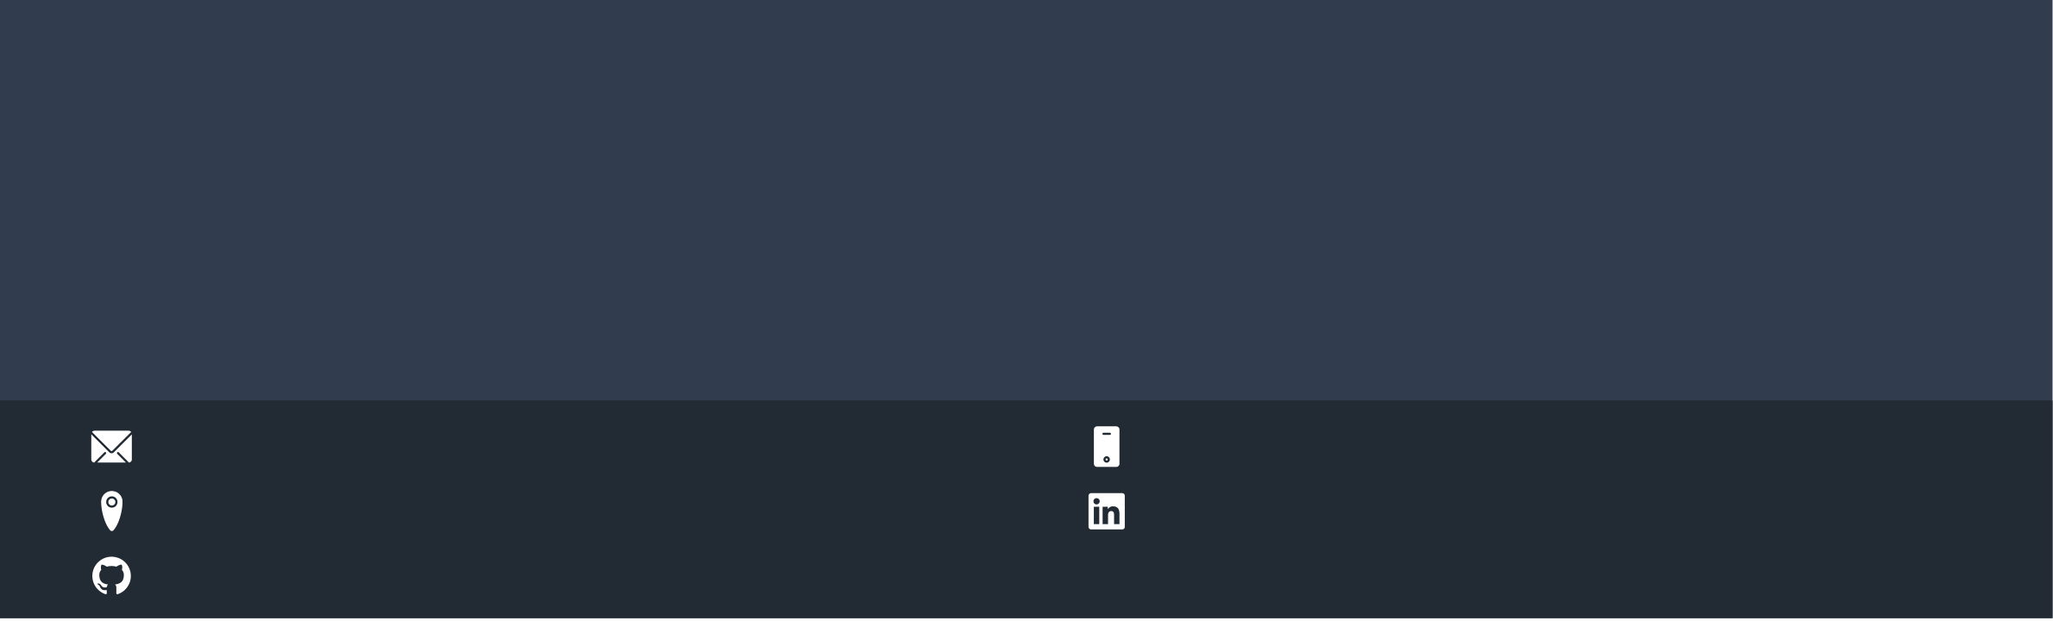

Paras Thakkar

Aspiring Software Engineer

I love to learn new technologies and passionate about whatever I am working on. Seeking the position in growth oriented company where i can use my skills to help in the growth of company while having the scope to develop as well as diversify my professional skill-set. I am focused, dedicated and see my task through. I always make sure to complete my task within deadline.

[parasthakkar1206@gmail.com](mailto:parasthakkar1206@gmail.com)  +91 8983672458

Pune, India [linkedin.com/in/paras-thakkar-462096190](https://linkedin.com/in/paras-thakkar-462096190/)

[github.com/paras77-thakkar](https://github.com/paras77-thakkar)

|  |  |  |  |  |  |  |  |  |  |
| --- | --- | --- | --- | --- | --- | --- | --- | --- | --- |
| **EDUCATION** | | **TECHNICAL SKILLS** | | | | | | |  |
| **Bachelor in Technology in Computer Science and** | | |  | | --- | | HTML | | |  | | --- | | CSS | | |  | | --- | | C | | |  | | --- | | C++ | | | |  | | --- | | Flutter | | |  | | --- | | Dart | |  |
| **Engineering** | |
| |  | | --- | | Python | | |  | | --- | | Data Analysis | | | | |  | | --- | | Data Visualization | | | |  |
| D.Y Patil International University Pune | | Git |
| *08/2020 - 05/2023*, | *7.6 CGPA* | |  | | --- | | GitHub | | |  | | --- | | Ms Office | | | | | | |  |

**Diploma in Computer Engineering**   
K.J Somaiya Polytechnic Mumbai

|  |  |  |
| --- | --- | --- |
| *08/2016 - 05/2019*, | *86.20%* | **COURCES** |

**SSC**   
Sharda Vidyalaya Padgha, Thane

100 Days of Code: The Complete Python Pro Bootcamp (Udemy) (05/2022)

*06/2015 - 03/2016*, 2021 Flutter Development Bootcamp (Udemy) (12/2021)

Data Analysis with Python(Coursera) (06/2021)

|  |  |
| --- | --- |
| **PROJECTS** | Data Visualization with Python(Coursera) (06/2021) |

Neuroscience Dataset Analysis (06/2021 - 07/2021)

Analyze patient’s Information using different parameters, extracted some specific records(outliers), prediction of some parameters for future, and visualize that information graphically etc

Personal Expenses Tracker App (05/2021 - 05/2021)

Microsoft Azure one day workshop (06/2021) *Introduction to Data Science and AI*

Programming for Everybody (Getting Started with Python) (Courseera) (07/2020)

|  |  |
| --- | --- |
| Helps user to add personal expenses and track his weekly expenses. | Web Development Course(Coursera) (01/2020) |

Student Portal (02/2021 - 04/2021)

|  |  |  |
| --- | --- | --- |
| Website for students and teacher/admin to give exam, apply for leave, add | **LANGUAGES** |  |
| and display student’s personal information etc.) |
| Question Paper Generator System (02/2019 - 04/2019) | English | Marathi |
|  |
| User just have to add questions and system generates question paper in | *Professional Working Proficiency* | *Professional Working Proficiency* |
| particular pattern by picking questions randomly. |
| Hindi | Gujarati |
| *Professional Working Proficiency* | *Native or Bilingual Proficiency* |

**WORK EXPERIENCE**

|  |  |
| --- | --- |
| **Flutter App Developer Intern** | **INTERESTS** |

Zoob Labs

|  |  |  |  |  |  |  |  |  |
| --- | --- | --- | --- | --- | --- | --- | --- | --- |
| *11/2021 - 12/2021*, | *Delaware, US* | Cricket | |  | | --- | | Football | | |  | | --- | | Travelling | | |  | | --- | | Quotes Writing | |
| *Zoob Labs, Inc. is a Delaware, US based startup - focused on creating platforms for* | |

*making the world kinder and filled with happiness.*

*Achievements/Tasks*   
Focusing or on frontend App Development.   
Debugging and solving errors.

Code Documentation.

**Neuroscience Dataset Analysis**   
D.Y. Patil International University   
*06/2021 - 07/2021*, *Pune ,India*   
*Achievements/Tasks*   
 Analyze patient’s Information using different parameters.

Performing EDA(Exploratory Data Analysis).

Code Documentation.